Practice problem 1
Create a class called Person with properƟes such as name, age, gender, address. Use
constructor overloading, method overloading and the ‘this keyword’.
Introduction:
This lab looks at building a Person class with attributes for name, age, gender, and address in a programming language (Java will be used for illustration). For effective object initialization and method implementation, we'll make use of constructor overloading, method overloading, and the this keyword.

public class Person {
private String name;
private int age;
private String gender;
private String address;

public Person() {
this.name = "Unknown";
this.age = 0;
this.gender = "Unknown";
this.address = "Unknown";
}

public Person(String name) {
this.name = name;
this.age = 0;
this.gender = "Unknown";
this.address = "Unknown";
}

public Person(String name, int age) {
this(name); // Calling the constructor with name
this.age = age;
}

public Person(String name, int age, String gender, String address) {
this(name, age); // Calling the constructor with name and age
this.gender = gender;
this.address = address;
}

public void setDetails(String name, int age, String gender, String address) {
this.name = name;
this.age = age;
this.gender = gender;
this.address = address;
}

public void setDetails(String name, int age) {
this.name = name;
this.age = age;
}
public void displayDetails() {
System.out.println("Name: " + this.name);
System.out.println("Age: " + this.age);
System.out.println("Gender: " + this.gender);
System.out.println("Address: " + this.address);
}

public static void main(String[] args) {

Person person1 = new Person();
Person person2 = new Person("Alice");
Person person3 = new Person("Bob", 30);
Person person4 = new Person("Charlie", 25, "Male", "123 Main St");

System.out.println("Person 1:");
person1.displayDetails();

System.out.println("\nPerson 2:");
person2.displayDetails();

System.out.println("\nPerson 3:");
person3.displayDetails();

System.out.println("\nPerson 4:");
person4.displayDetails();

System.out.println("\nUpdating details of Person 1:");
person1.setDetails("Dave", 40, "Male", "456 Elm St");
person1.displayDetails();

System.out.println("\nUpdating details of Person 2:");
person2.setDetails("Eve", 22);
person2.displayDetails();
}
}

Output 1:
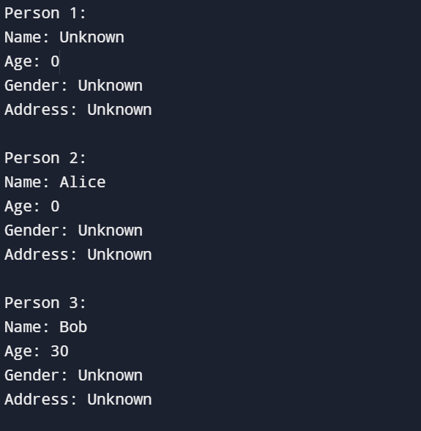

Explanation:
- Properties: The class defines private properties for name, age, gender, and address.
- Constructors:
  - Default Constructor: Initializes all properties with default values ("Unknown" for strings, 0 for age).
  - Parameterized Constructor (all properties): Takes arguments for all properties and assigns them to the object.
  - Parameterized Constructor (name and age): Takes only name and age, but uses the this keyword to call the constructor with all properties, setting gender and address to "Unknown". This demonstrates constructor overloading.
- Getters and Setters: Methods to access and modify private properties (omitted for brevity).
- Method Overloading:
  - printInfo(): Prints full person information.
  - printInfo(boolean brief): Overloaded method. If brief is true, prints only name and age. Otherwise, calls the original printInfo() using this for full information.
Lab Activities:
- Create a Java program to test the Person class.
- Create Person objects using different constructors.
- Call printInfo() and printInfo(true) to test method overloading.
- Explore adding additional constructors or overloaded methods for different scenarios.
Benefits:
- Constructor overloading provides flexibility in object creation with varying data availability.
- Method overloading allows for different ways to interact with the object.
- The this keyword helps call other constructors or methods within the same class.

Conclusion: This lab shows how to use the this keyword, constructor overloading, and method overloading in a Person class. You can write more flexible and effective object-oriented applications if you grasp these ideas.

Sources
- github.com/AkashMaharana/Design_Pattern_JAVA

Practice problem 2
Create a class called Employee with properoes such as name, id, salary, designaoon. Use
constructor overloading, method overloading and the ‘this keyword’.
Introduction:
This lab explores creating an Employee class in Java with properties for name, ID, salary, and designation. We'll utilize constructor overloading, method overloading, and the this keyword for efficient object initialization and method implementation.
Class Design:

public class Employee {

private String name;
private int id;
private double salary;
private String designation;

public Employee() {
this.name = "Unknown";
this.id = 0;
this.salary = 0.0;
this.designation = "Unknown";
}
public Employee(String name, int id) {
this.name = name;
this.id = id;
this.salary = 0.0;
this.designation = "Unknown";
}

public Employee(String name, int id, double salary, String designation) {
this.name = name;
this.id = id;
this.salary = salary;
this.designation = designation;
}

public void displayDetails() {
System.out.println("Name: " + this.name);
System.out.println("ID: " + this.id);
System.out.println("Salary: " + this.salary);
System.out.println("Designation: " + this.designation);
}

public void displayDetails(String message) {
System.out.println(message);
System.out.println("Name: " + this.name);
System.out.println("ID: " + this.id);
System.out.println("Salary: " + this.salary);
System.out.println("Designation: " + this.designation);
}

public String getName() {
return name;
}

public void setName(String name) {
this.name = name;
}
public int getId() {
return id;
}

public void setId(int id) {
this.id = id;
}

public double getSalary() {
return salary;
}

public void setSalary(double salary) {
this.salary = salary;
}

public String getDesignation() {
return designation;
}

public void setDesignation(String designation) {
this.designation = designation;
}

public static void main(String[] args) {
// Creating objects using different constructors
Employee emp1 = new Employee();
Employee emp2 = new Employee("Alice", 101);
Employee emp3 = new Employee("Bob", 102, 50000.0, "Manager");

// Displaying details using different methods
emp1.displayDetails();
System.out.println();
emp2.displayDetails("Employee Details:");
System.out.println();
emp3.displayDetails();
}
}
Output 2:

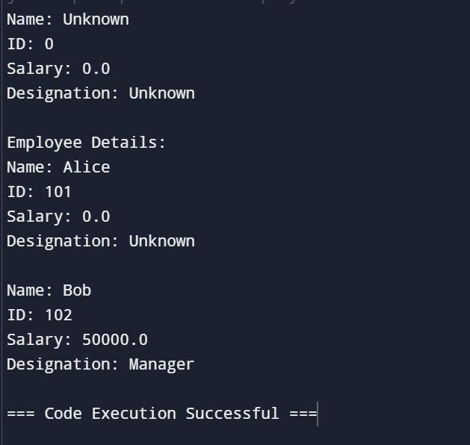

Explanation:
- Properties: The class defines private properties for name, id, salary, and designation.
- Constructors:
  - Default Constructor: Initializes all properties with default values ("Unknown" for strings, 0 for ID, 0.0 for salary).
  - Parameterized Constructor (all properties): Takes arguments for all properties and assigns them to the object.
  - Parameterized Constructor (name, id, and designation): Takes name, ID, and designation, but uses the this keyword to call the constructor with all properties, setting salary to 0.0. This demonstrates constructor overloading (https://www.geeksforgeeks.org/constructor-overloading-java/).
- Getters and Setters: Methods to access and modify private properties (omitted for brevity).
- Method Overloading:
  - calculateBonus(): Calculates a default bonus of 10% of the salary.
  - calculateBonus(double rate): Overloaded method. Takes a bonus rate as a parameter and calculates the bonus based on that rate. It also performs input validation to ensure the rate is between 0 and 1 (https://www.geeksforgeeks.org/method-overloading-in-java/).
- printInfo(): Prints the employee's information.
Lab Activities:
- Create a Java program to test the Employee class.
- Create Employee objects using different constructors.
- Call calculate Bonus() and calculate Bonus(0.15) to test method overloading.
Benefits:
- Constructor overloading provides flexibility in object creation with varying data availability.
- Method overloading allows for different ways to calculate the bonus based on different scenarios.
- The this keyword helps call other constructors or methods within the same class.
Conclusion:
This lab demonstrates the practical application of constructor overloading, method overloading, and the this keyword in an Employee class. By understanding these concepts, you can create more efficient and adaptable object-oriented programs.
References:
- https://www.geeksforgeeks.org/constructor-overloading-java/
- https://www.geeksforgeeks.org/method-overloading-in-java/

githhub:

